Nicholas Ang

CS457

Project Assignment 1

PA1 Design Document

Databases are organized as directories. Folder and database names are unique. When a user creates a database, a folder with its user-given name is created in the same folder as the compiled program. The user can create as many databases as they want, given that each name is unique. Databases cannot be created within another database and only tables are able to be manipulated within a database. While using a database, users cannot create or drop databases. Users can only manipulate tables while using a database.

Tables are organized into files. File and table names are unique. Tables are manipulated using create, drop, alter, and select commands. Tables can only be manipulated while a database is in use. When a user creates a table, a file with its user-given name is created within the currently used database. The user can create as many tables as they want, given that each name is unique. Attributes and parameters are organized within each file with attributes taking up one line each.

The program creates a simple database system that allows users to create, drop, and use databases with functions to create, drop, alter, and select tables. The “CREATE DATABASE” command creates an empty folder with the database’s name. If a database has that database’s name, it outputs an error message since the database already exists. The “DELETE DATABASE” command deletes a folder with the database’s name and all the files that are inside the database. The “USE” command switches the current directory in use to the database with its user-given name. For the delete and use commands, if there is not a database that has that database’s name, it outputs an error message since the database does not exist. Tables have four corresponding commands. These commands can only be used while a database is in use. The “CREATE TABLE” command creates a text file with the table name and writes the attributes inside the file. Each attribute takes one line each in the file. If a table has that table’s name, it outputs an error message since the table already exists. The “DROP TABLE” command deletes the file with the table’s name. The “ALTER TABLE” command only supports “ADD” and appends new attributes to the table file. The “SELECT * FROM” command queries the table and outputs the attributes within the table. For the delete, alter, and select commands, if there is not a table that has that table’s name, it outputs an error message since the table does not exist. Users exit the program by using the command “.EXIT”.

The program is compiled inside the folder with the p1.cpp file using *g++ p1.cpp -o p1* in the terminal.

Calling the program without any file arguments *./p1* opens the program in interactive mode. Users can type in the commands to use the database system.

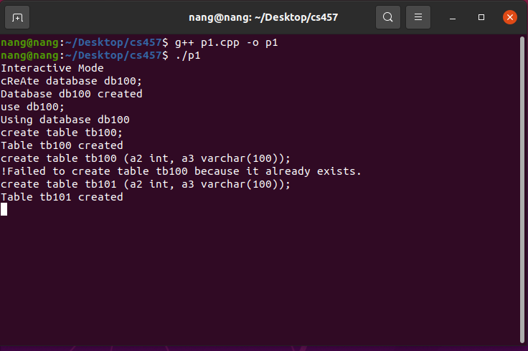

The program can also be used with file arguments with the command *./p1 “File Name”*. It parses all the commands in the file and executes them.

Example Use: *./p1 PA1_test.sql*

